|  |  |  |  |  |  |
| --- | --- | --- | --- | --- | --- |
|  |  | |  | | |
| **ENGLISH**  Beginners  ---------------------------------------------------------  Session 2. Numbers (how many…?) | | |
|  | | |
| INTRODUCTION | | | |  |  |
|  | |  | HOW MANY...? - (Quantity) **How many** is used when we want to know the **quantity** of something.  It is only used with plural countable nouns. HOW MANY + PLURAL NOUN  * **How many** days are there in January? * **How many** people work in your company? * **How many** cousins do you have? * **How many** books did you buy? * **How many** countries are there in the world? * **How many** students are in the class right now? * **How many** chairs are there in this room? * **How many** pieces of chocolate would you like? | | |

­­

**HOW MANY…?**

Si se trata de sustantivos *contables*, se aplica **How many**.

**There is and there are**

A estas preguntas se responde usando **There is / are**, dependiendo de si se trata de singular o plural.

THERE IS (SINGULAR) There is a pencil

THERE ARE (PLURAL) there are two (three, four…) pencils.

**Example:**

**How many cars do you have?**¿Cuántos autos tienes?

**How many cars are there?**¿Cuántos autos hay?



**There are four cars.**Hay cuatro autos.

|  |
| --- |
| **How many monkeys?**  [**¡Clic here!**](https://www.youtube.com/watch?v=bUvbOtOGeUs#t=26)  **What number?**  [**¡Clic here!**](http://www.englishforeveryone.org/PDFs/What_Number.pdf) |

**Activity:**

How many circles are there?

How many triangles are there?

How many squares are there?

How many stars are there?

How many triangles are there?

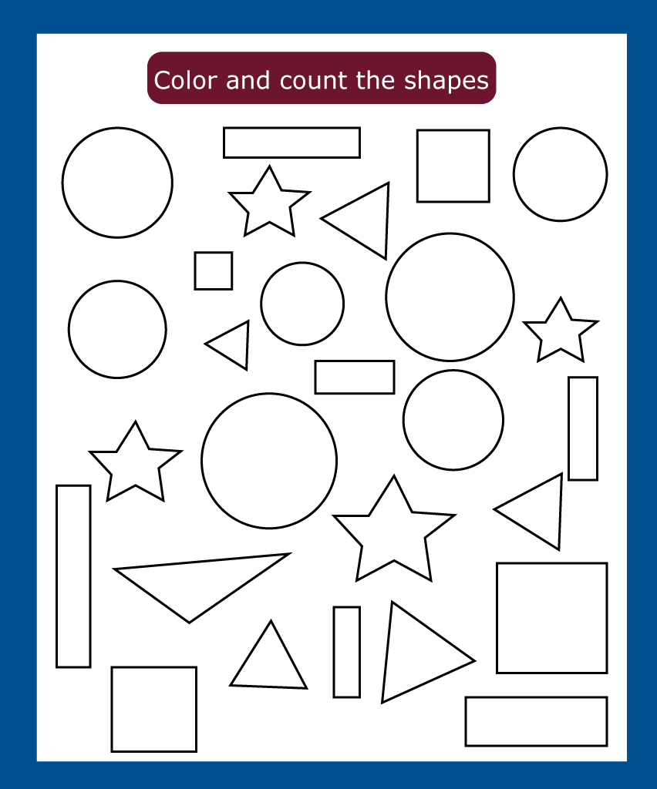

|  |  |  |  |
| --- | --- | --- | --- |
| 1. **Color all e circles in red.** | 1. **Color all the squares blue**. | | 1. **Color all the stars green.** |
| 1. **Color all the triangles purple.** | | **Color all the rectangles orange.** | |

|  |  |  |
| --- | --- | --- |
| BIBLIOGRAPHY |  |  |

|  |  |
| --- | --- |
|  | * [**http://www.saberingles.com.ar/curso/lesson07/04b.html**](http://www.saberingles.com.ar/curso/lesson07/04b.html) |